Exercise 3.1

Part 1
Input | Output | t_{pd_LH} | t_{pd_HL}
Low-high | High-low | N/A | 0.0706 ns
High-low | Low-high | 0.0206 ns | N/A

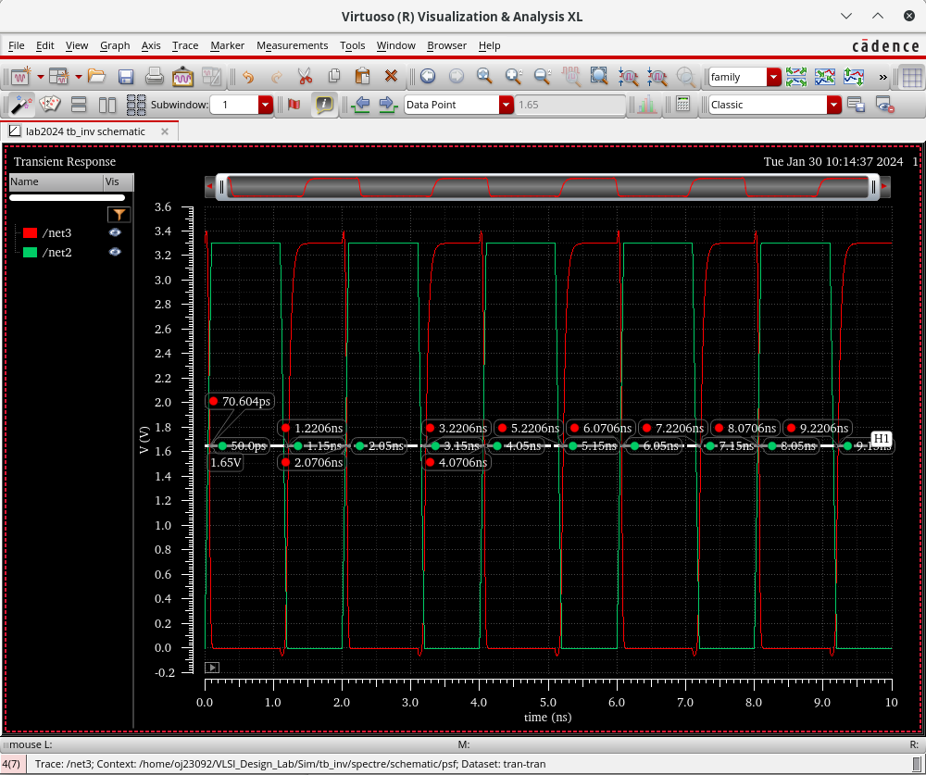

Part 3

(do the derivation)

t_{pd_LH} = 0.69*R_{p}*C_{L}
R_{p} = 2985.5 Ω

Part 4

R_{p} = R_{p, min} x W_{min}/W x L/L_{min}

R_{p, min} = 2985.5 x 2/1 * 0.35/0.35 = 5971 Ω

(After Simulation)

Input | Output | t_{pd_LH} | t_{pd_HL}
Low-high | High-low | N/A | 0.15662 ns
High-low | Low-high | 0.06964 ns | N/A

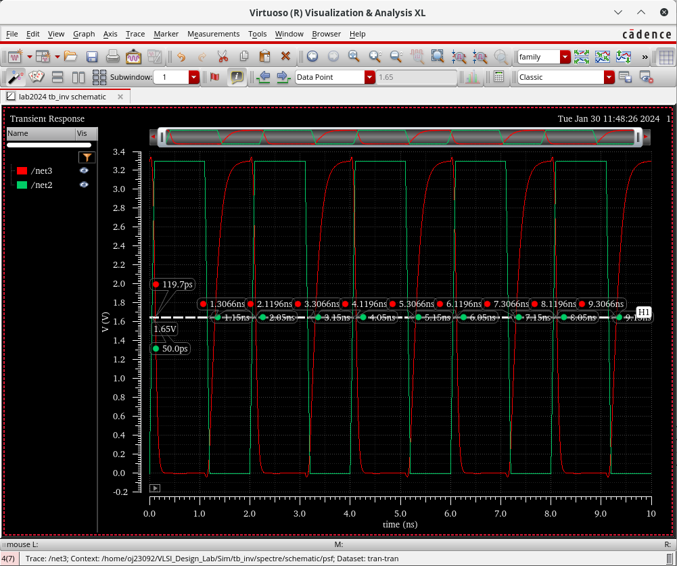

R_{p} = 8410.63 Ω

R_{p, min} = 8410.63 Ω

Part 5

t_{pd_HL} = 0.69 x R_{n} x C_{L}

R_{n} = 9338.62 Ω

R_{n, min} = 9338.62 * 1/1 * 0.35*0.35 = 9338.62 Ω

______
Notes: recheck part 4 simulation results

Exercise 3.2
Part 1
(See ODS Notebook for derivation values)
PMOS W/L = 1.45/0.35 (mu m)
NMOS W/L = 1.61/0.35 (mu m)

Part 2
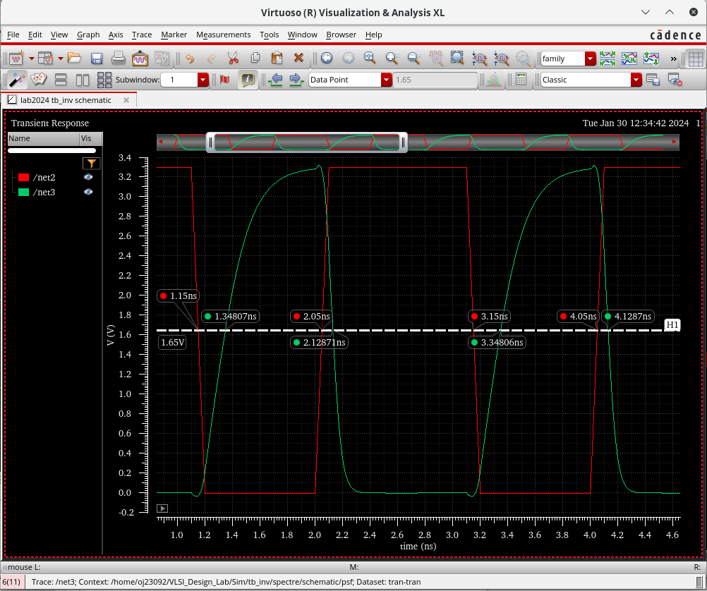

Input | Output | t_{pd_LH} | t_{pd_HL}
Low-high | High-low | N/A | 0.0787 ns = 78.7 ps
High-low | Low-high | 0.19807 ns = 198.07 ps | N/A

